**Traffic sign classification**

--- Stage 2 (Motivation and problem definitions)

Team: Chenxu Zhuang, Lei Mu, Yangjian Xiao

1. Motivation

Image recognition is of great significance and has already been utilized in different areas. For example, the traffic sign classification is one of the most significant skills, which must be considered in designing self-driving cars. Such ability is the first step to make a right decision during the driving, such as turning right, stop, speeding up, etc. Therefore, developing a reliable framework to handle real-time traffic sign detection and recognition is a real traffic situation is needed.

1. Problem definitions

In real situations, a self-driving car will encounter a number of traffic signs with different background colors and symbols. Making the right classification for such photos and extracting the accurate information ensure the safety during self-driving. A dataset is available online, including 43 typical types of traffic signs, such as speed limit, animal crossing, stop sign, etc. A photo of these signs is shown in Figure 1.

In our project, a machine learning-based algorithm will be developed to make traffic sign classification. Details concerning program running time, accuracy, will be extensively analyzed in the next stage.

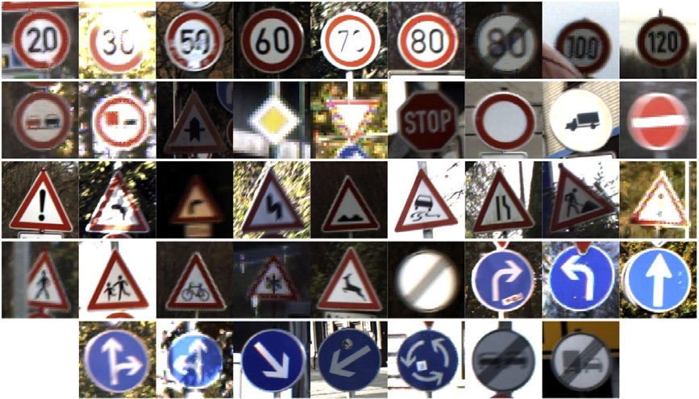

**Figure. 1**